**List of top 10 IT companies in Sri Lanka**

1. Virtusa
2. Nexdin
3. 99X Technology
4. Codegen
5. Wso2
6. Xiteb
7. Johnkeellsit
8. Epictechnology
9. Arimaclanka
10. Syscolabs

Now I’m going to write down my case study of **WSO2** IT Company.

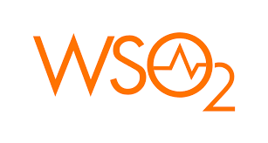

**History of WSO2**

WSO2 was founded in 2005 by *Sanjiva Weerawarana* and *Paul Fremantle* -- two former IBM employees. Weerawarana quit his job at IBM first and established the framework for the business in Sri Lanka; Fremantle joined him soon after. The original name for the company was Serendib Systems.

James Clark -- technical lead of the working group that developed XML -- was an original investor in Weerawarana and Fremantle's company. He requested that the founders change the company's name, believing Serendib Systems to not be attractive or memorable. As a result, Weerawarana and Fremantle decided on WSO2 -- inspired by a combination of **web services** **(WS)** and **oxygen (O2).**

**WSO2 Mission, Vision**

**WSO2 Mission Statement**

Proven Fortune 500 Partner. Leading enterprises rely on WSO2 for their mission-critical applications. Today, our customers span across healthcare, finance, retail, manufacturing, telecoms and other industries worldwide.

**WSO2 Vision Statement**

Helping Make Digitally Driven Organizations Become Integration Agile

**Company technology focus**

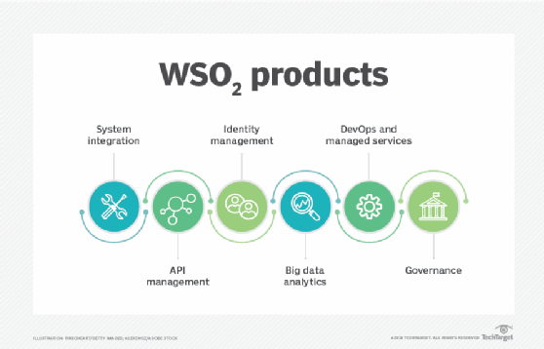

**WSO2 Enterprise Integrator (WSO2 EI)** -- WSO2 EI is the core of the WSO2 platform. It is an open source integration product for [container](https://www.techtarget.com/searchitoperations/definition/container-containerization-or-container-based-virtualization)-native and cloud-native projects that contains message brokering, visual tools, integration runtimes, business process modeling and analytics tools. WSO2 EI provides users with the choice between graphical or drag-and-drop, configuration-driven integration.

**WSO2 Enterprise Service Bus (WSO2 ESB)** -- WSO2 ESB is a completely open source, high-performance, lightweight and comprehensive [enterprise service bus](https://www.techtarget.com/searchapparchitecture/definition/Enterprise-Service-Bus-ESB). This product addresses integration standards and provides support for all integration patterns. WSO2 ESB enables interoperability between various business applications and heterogenous systems.

**WSO2 Identity Server (WSO2 IS)** -- The WSO2 IS product is used for load and access management; it makes it possible to manage the identity, security and privacy of a digital business. The WSO2 IS connects and controls various identities across multiple applications, the cloud, [internet of things](https://internetofthingsagenda.techtarget.com/definition/Internet-of-Things-IoT) (IoT) devices and APIs, regardless of the standards used by each platform. Through the WSO2 Identity Server, users can perform logins from different locations, thus increasing employee productivity; user experiences are also improved.

**WSO2 API Manager** -- The WSO2 API manager is an open source, full lifecycle API management solution, incorporating a [Kubernetes](https://www.techtarget.com/searchitoperations/definition/Google-Kubernetes) operator that makes it easy to convert raw [microservices](https://www.techtarget.com/searchapparchitecture/definition/microservices) into managed APIs. The WSO2 API manager can run anywhere: on-premise, on a private cloud, on a hybrid cloud or distributed across various cloud and on-premise infrastructures.

**WSO2 IoT Server** -- The WSO2 IoT server provides a complete solution that allows enterprises and device manufacturers to provide scalability to the connection and control of various devices, creation of apps, securing of devices and data, [visualization](https://www.techtarget.com/searchbusinessanalytics/definition/data-visualization) of sensor data and event management.

**WSO2 Data Analytics Server (WSO2 DAS)** -- The WSO2 DAS allows users to benefit from business operations information in real time. [Geolocation](https://www.techtarget.com/searchmobilecomputing/definition/geolocation) capabilities also provide users with an improved experience. Furthermore, the WSO2 Data Analytics Server expands its solutions to provide analysis of past and present processes, allowing users to benefit by learning from the past and improving future operations. The WSO2 DAS product also allows users to create the opportunity of new sources of income through digital products.

**Company work culture**

The WSO2 culture is strong; one of radical reliance on open source principles of transparency, meritocracy, and individual responsibility. We work hard; constantly pushing the boundaries of innovation, and we play hard, with many company wide sporting events, celebrations, and charitable work.

**Clients and operating regions**

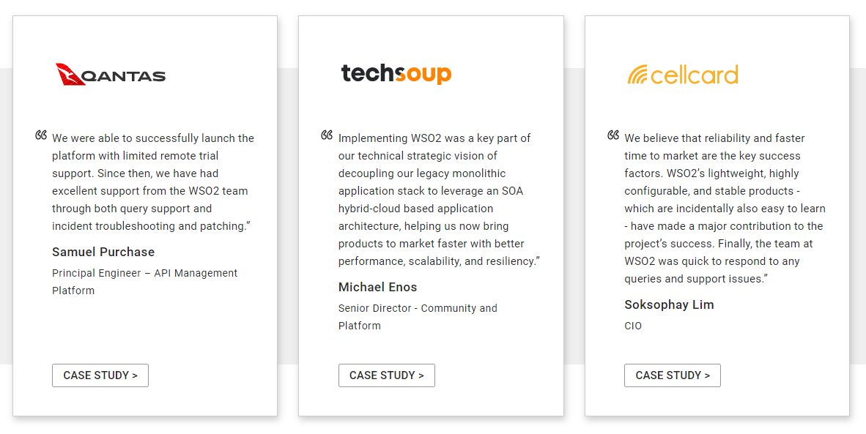

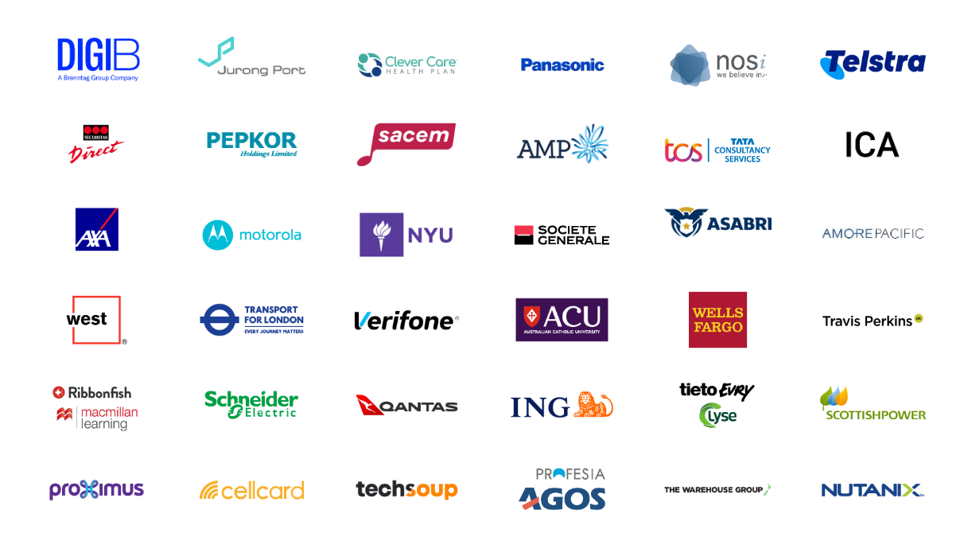

**Conclusion**

WSO2 is great place to work and learn !

**References**

* <https://www.techtarget.com/searchapparchitecture/definition/WSO2>
* <https://wso2.com/>
* <https://www.comparably.com/companies/wso2/mission>